

1LINK STANDARD IPSEC TEMPLATE OVER INTERNET WITH Ikev2

Dated: 15-Aug-2025

1LINK STANDARD IPSEC TEMPLATE OVER INTERNET WITH Ikev2
Note: To establish IPSec VPN over internet, firstly, Public IPs of both ends (1LINK’s end & customer’s end) should be reachable from devices on which IPSec VPN would be configured.
IKE Phase I policy:
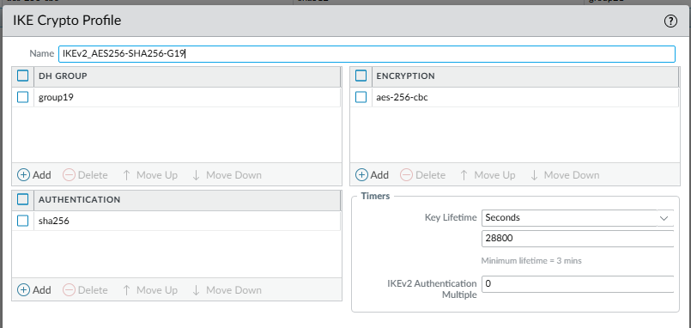
IKE Phase II policy
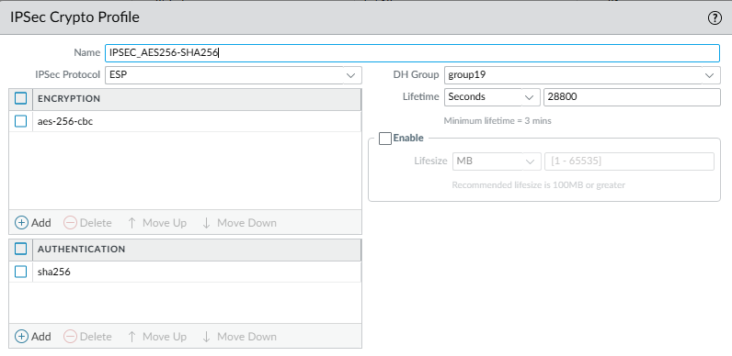
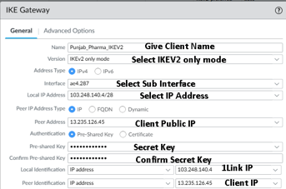

Interesting traffic access-list (Cisco standard)
Source IP | Source Subnet Mask | Destination IP |  |  | Destination Subnet Mask
 | 255.255.255.255 |  |  |  | 255.255.255.255
Subnet Address of Physical Interface on Switch
Customer interface IP
1Link Physical interface IP | 103.248.140.4

